**Tutorial 4- Feature Selection-Perform Feature Selection Using Information Gain For Regression In ML**

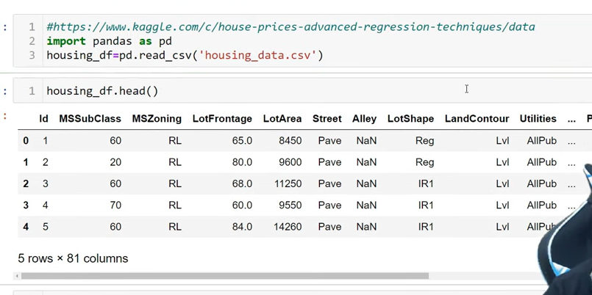

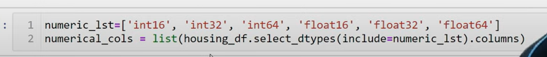

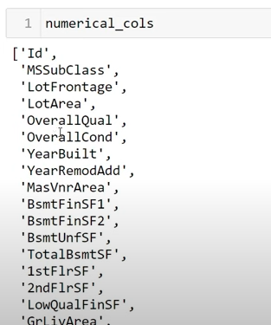

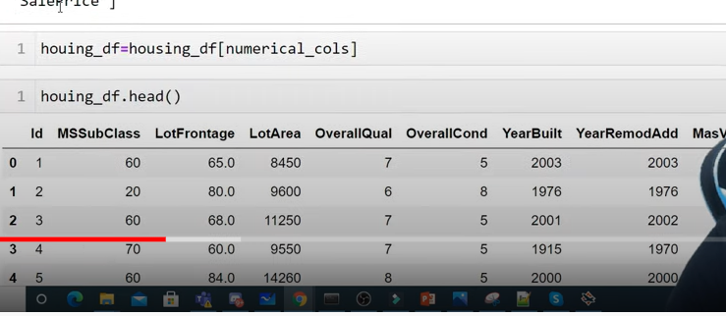

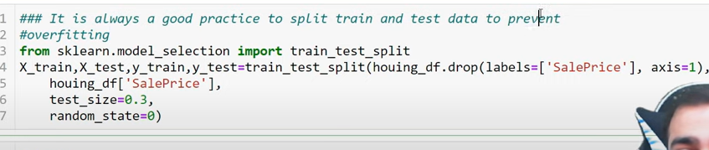

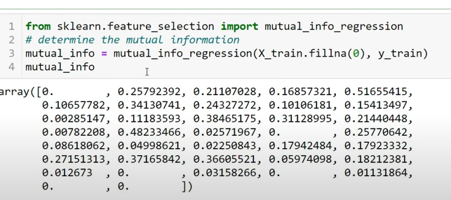

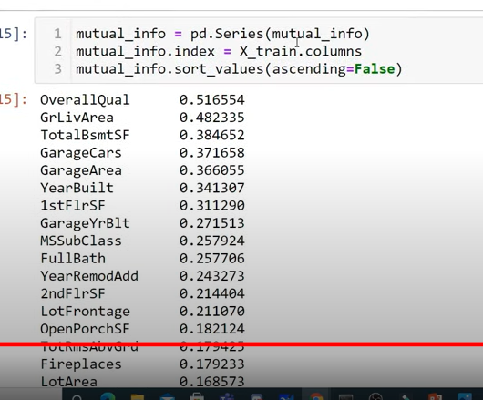

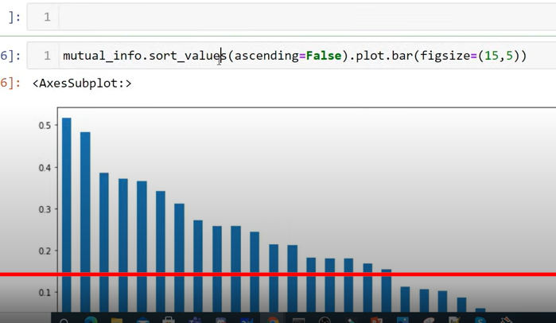

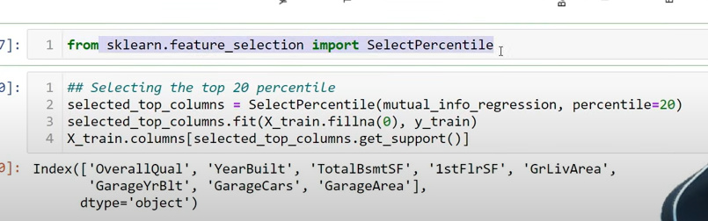

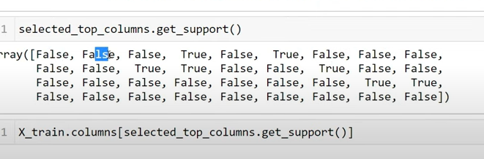

**Feature Selection-Perform Feature Selection Using Chi2 Statistical Analysis**

[Complete-Feature-Selection/5 - Chi Square For Feature Selection 1.ipynb at master · krishnaik06/Complete-Feature-Selection · GitHub](https://github.com/krishnaik06/Complete-Feature-Selection/blob/master/5%20-%20Chi%20Square%20For%20Feature%20Selection%201.ipynb)



Non negative features means features that are non negative values

Class is lable



Categorical independent variables with classification

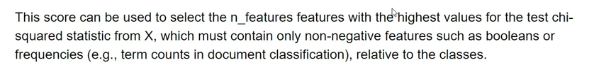

P value:

Highest chi square value is good feature

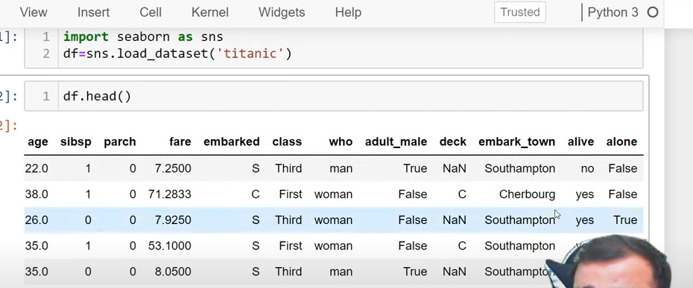

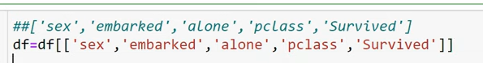

Before applying chi square test- do lable encoding

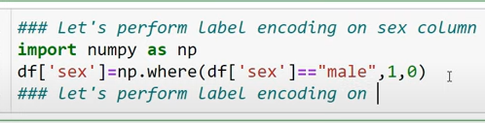

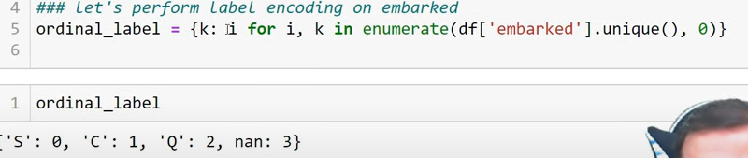

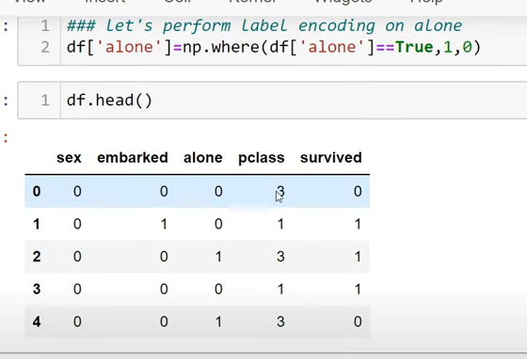

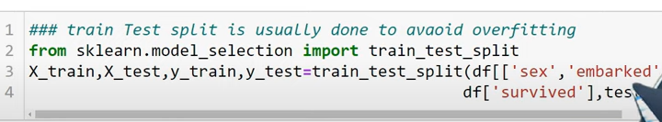

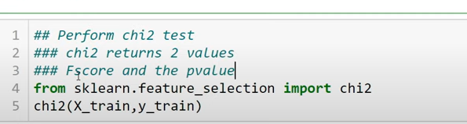

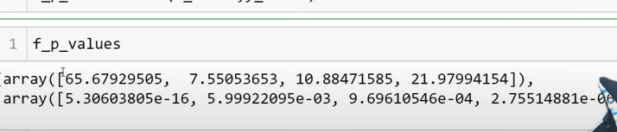

High f value – more imp that feature



less p value : most imp is the feature



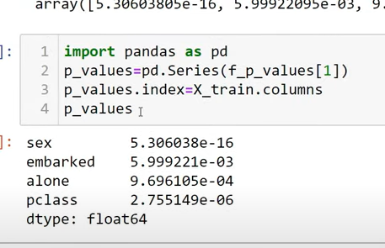

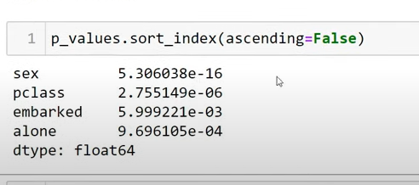

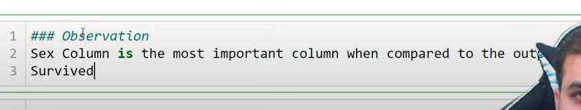

Feature importance technique:

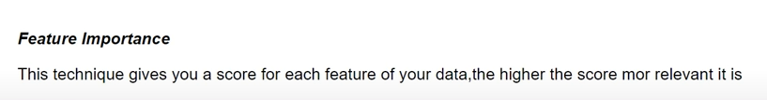

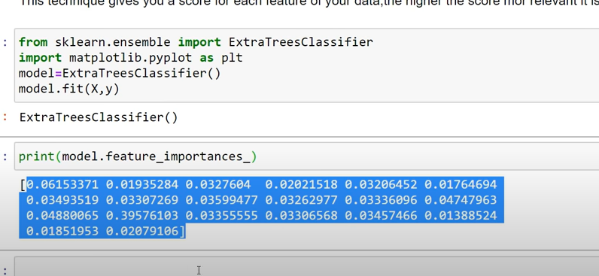

Higher the value relevant is the feature

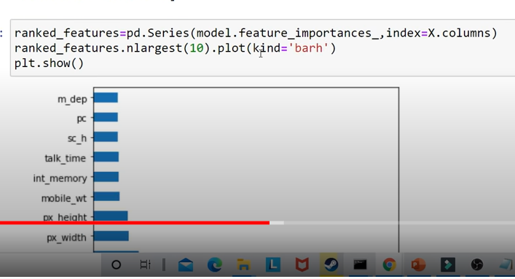

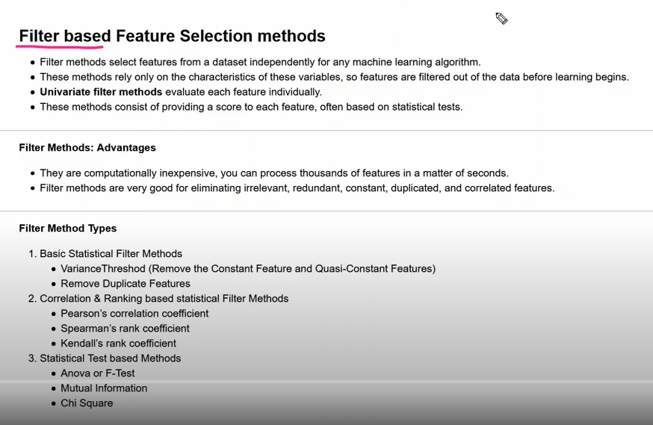

**Feature Selection using Remove Duplicate Numerical and Categorical Features - Tutorial 3**

[Feature Selection using Remove Duplicate Numerical and Categorical Features - Tutorial 3 - YouTube](https://www.youtube.com/watch?v=ud6n7iFzIqk&list=PLYkT78pxW-otjquYUvP_IcUBUYUbYygeu&index=3)

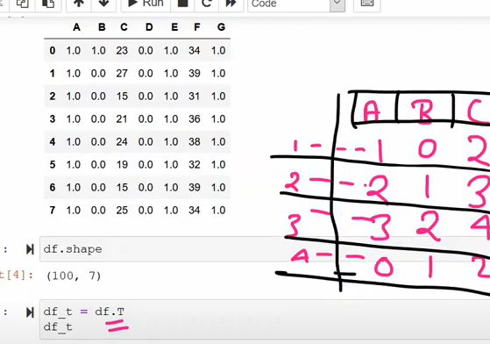

Above is transpose

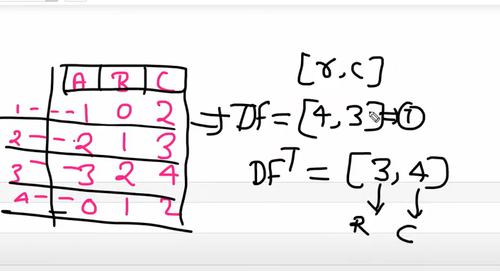

Rows and columns will be transposed

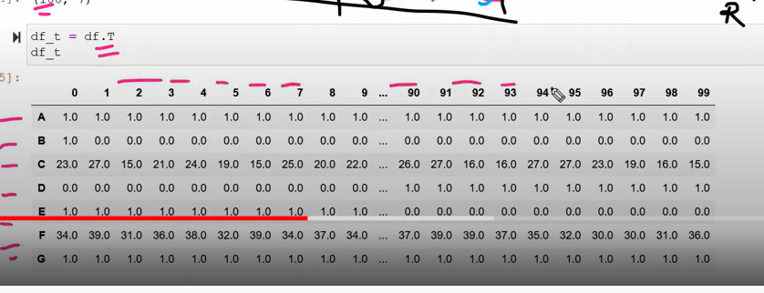

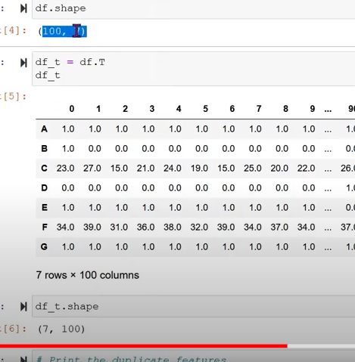

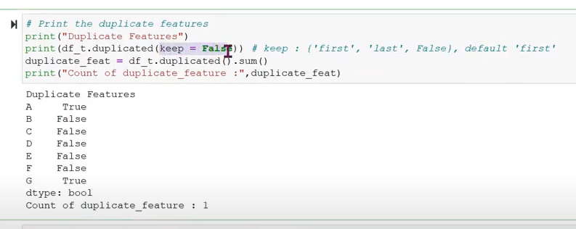

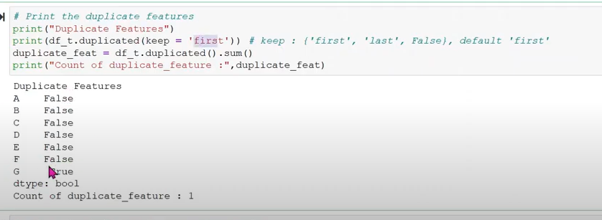

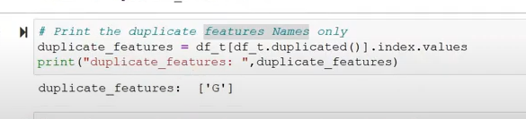

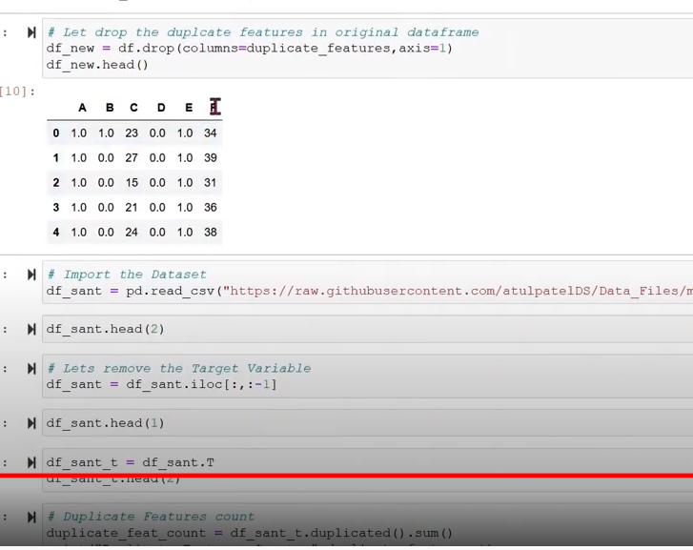

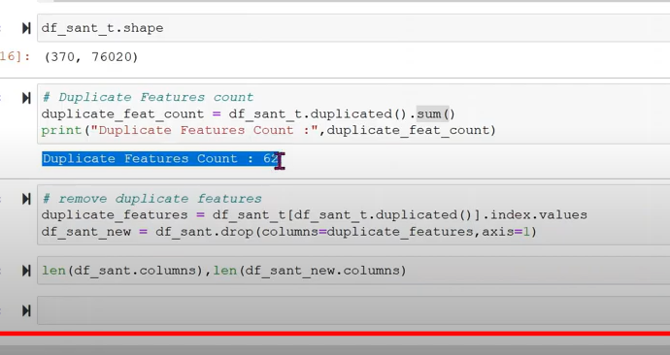

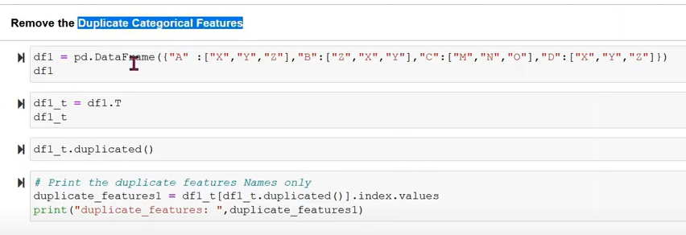

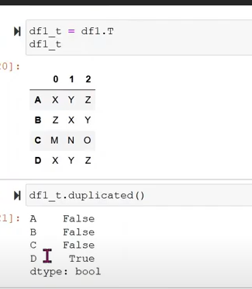

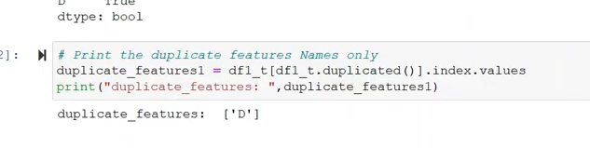

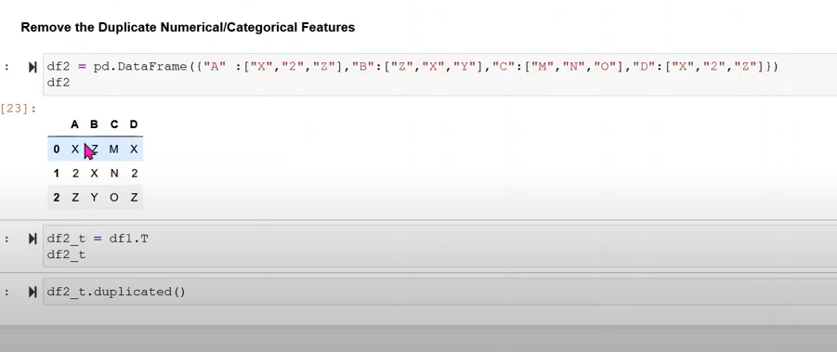

**Feature Selection using ANOVA Test for Classification and Regression - Tutorial 4**

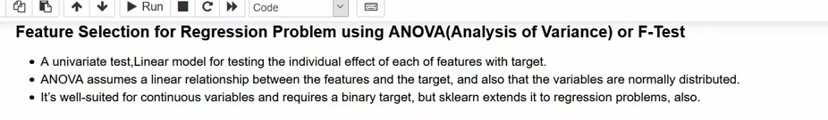

[Feature Selection using ANOVA Test for Classification and Regression - Tutorial 4 - YouTube](https://www.youtube.com/watch?v=wElwOM88xJQ&list=PLYkT78pxW-otjquYUvP_IcUBUYUbYygeu&index=4)

Regression :

Anova test

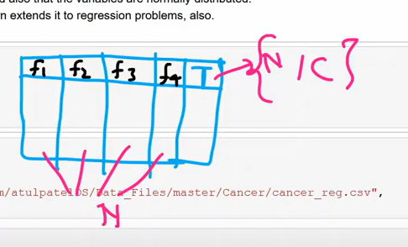

Features : numeric

Target = categorical or numerical

Classification or regression problems

It takes one independent features and dependent feature and produces fs1 score

2. it again take another independent features and dependent feature and produces fs2 score

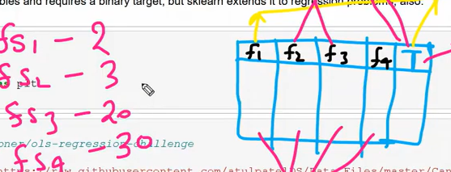

We will select features based on score

So called univariant analysis

Anova well suited if independent values are numeric and depend variable is categorical

**Now regression problem with anova**

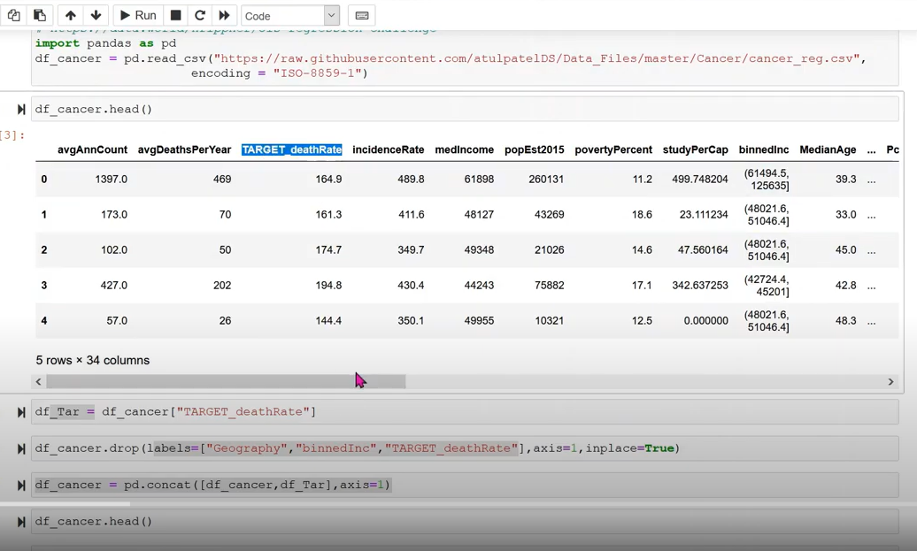

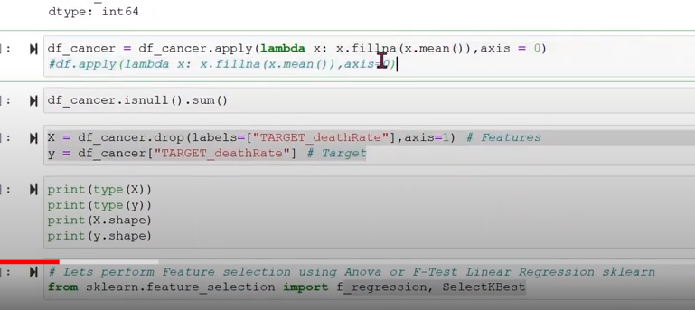

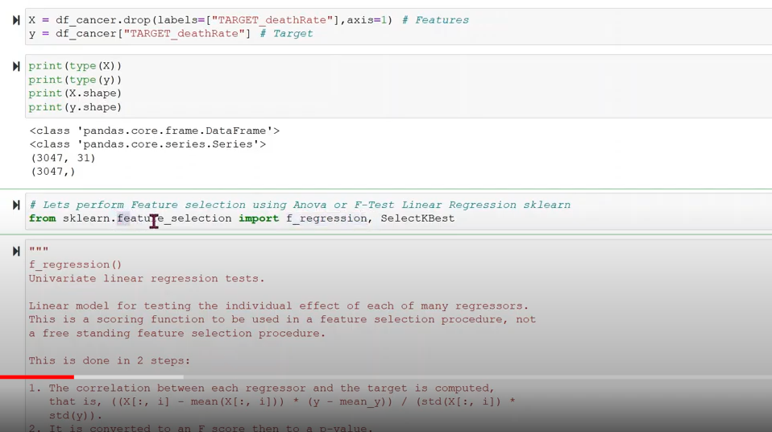

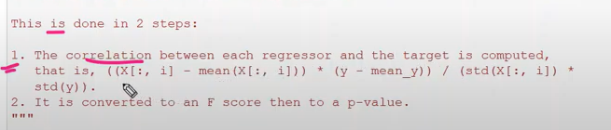

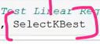

K=2

2 best features

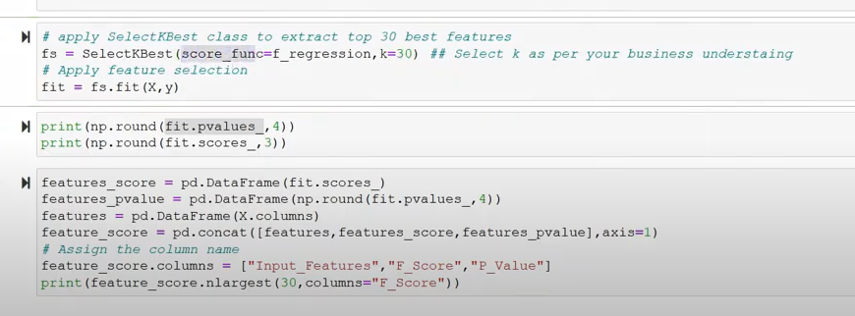

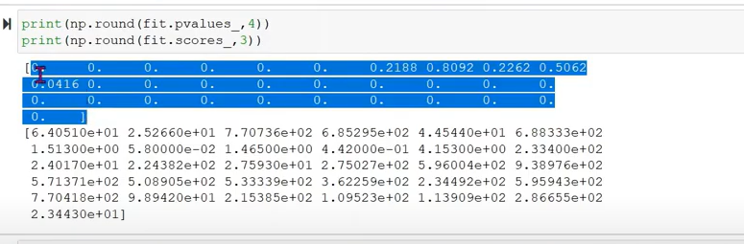

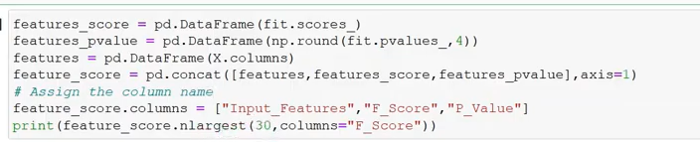

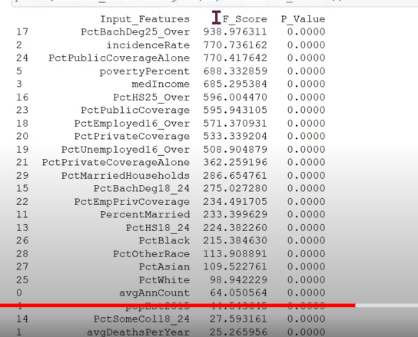



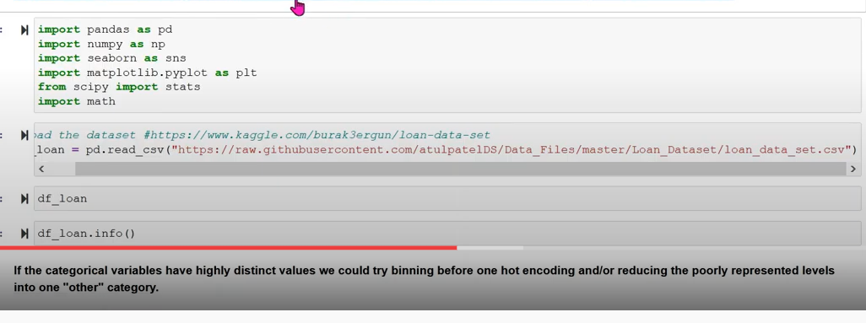

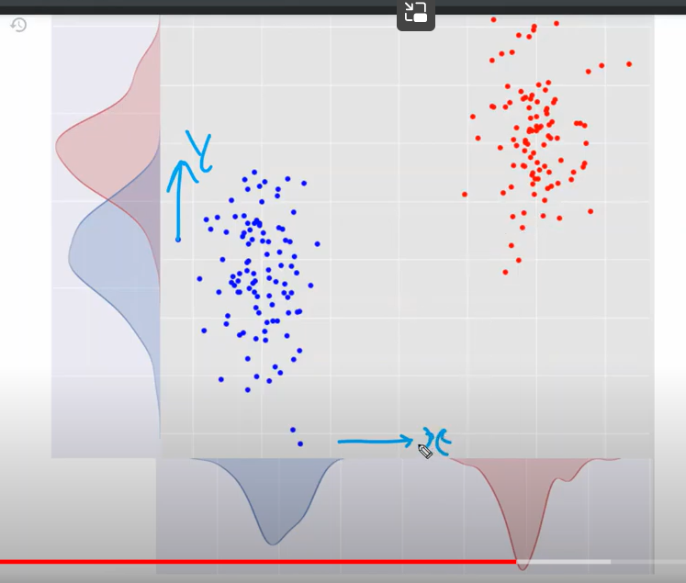

X feature is better separate than y

So f score will be higher for x and low for y

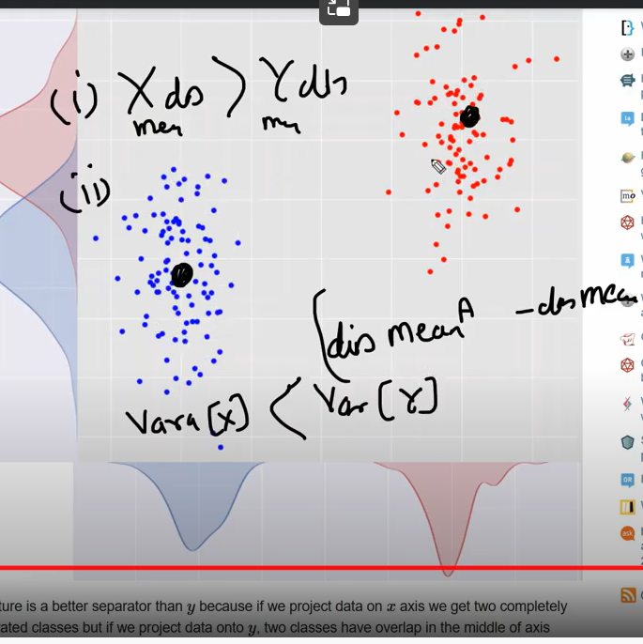

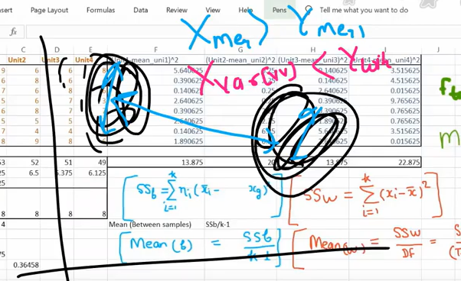

X variance within

Y variance within

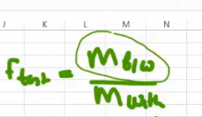

F test = mean b/w

Mean w/n

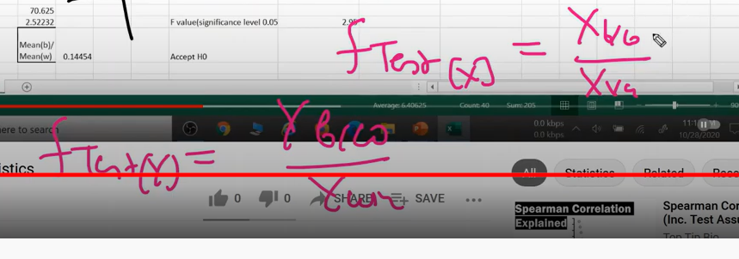

Ftext[x] is more than ftest[y]

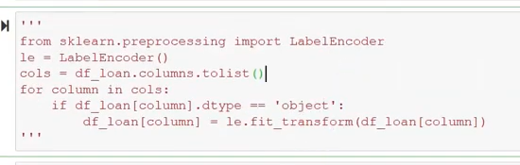

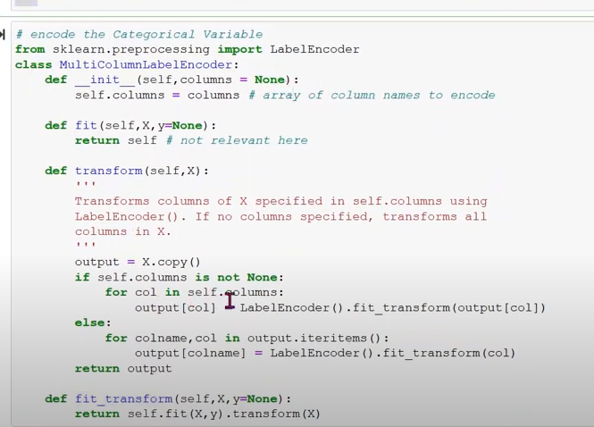

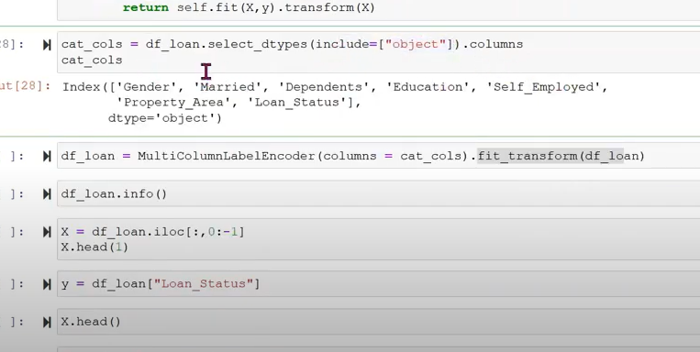

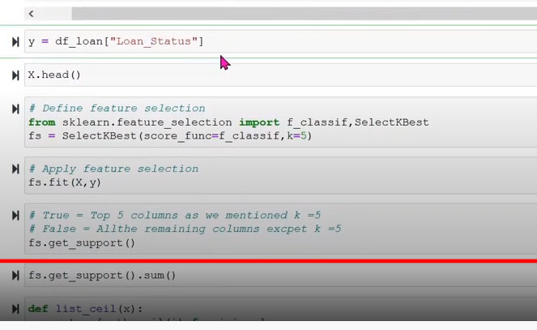

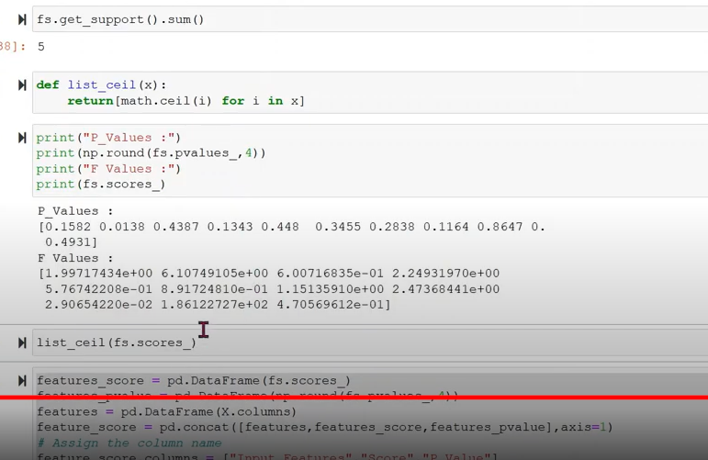

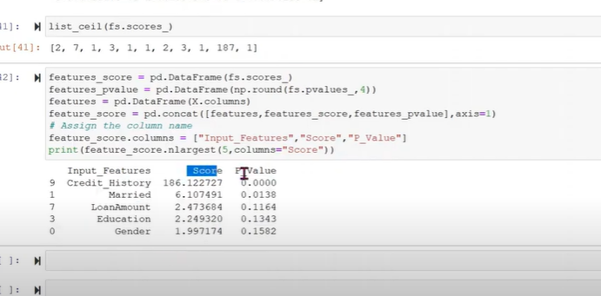

**Feature Selection using Correlation and Ranking Filter methods -Check Multi-collinearity- Tutorial 5**

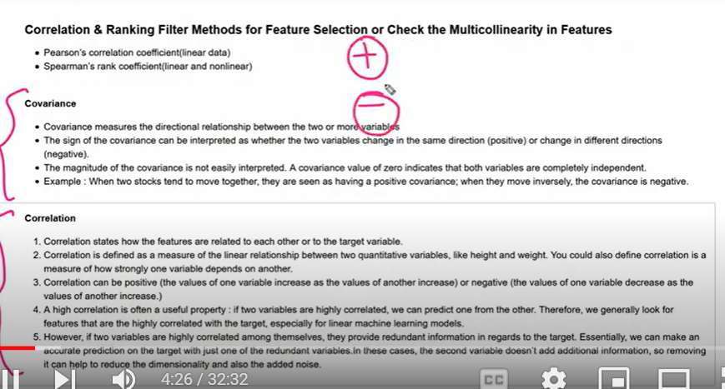

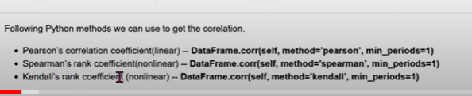

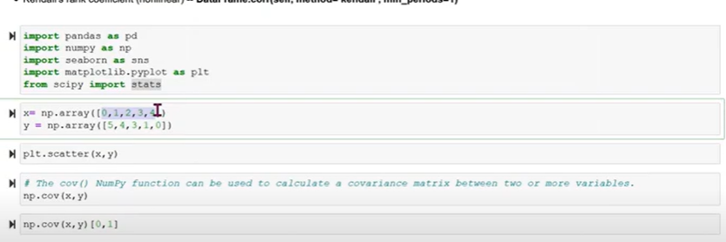

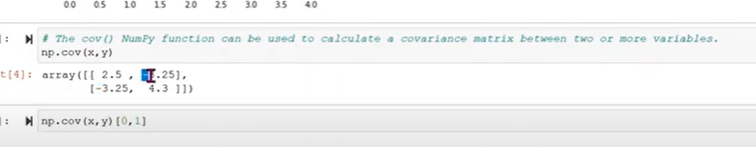

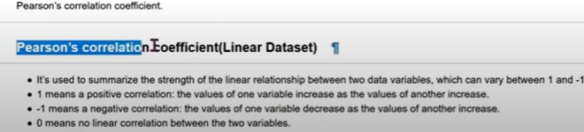

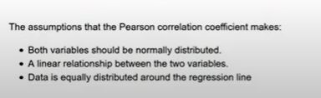

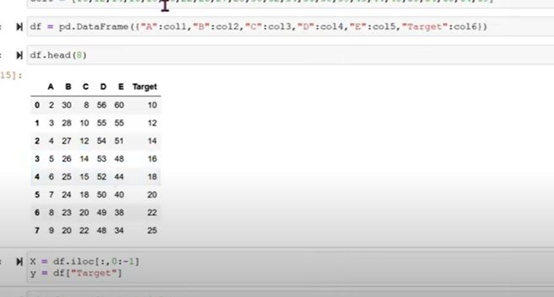

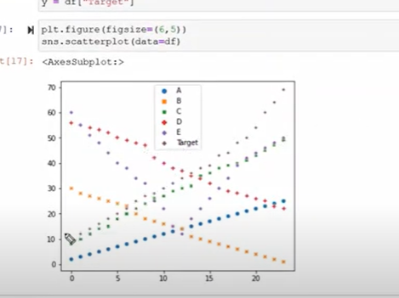

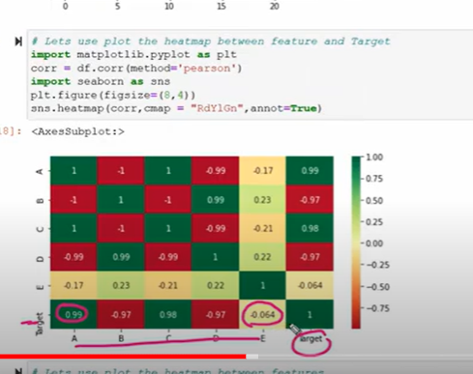

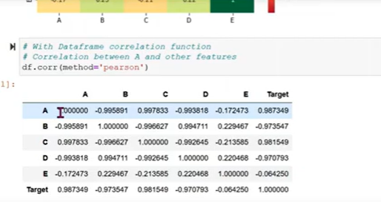

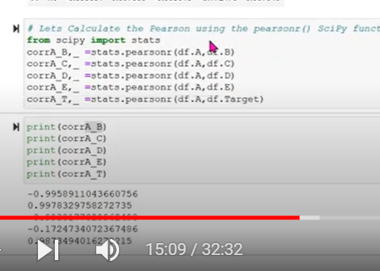

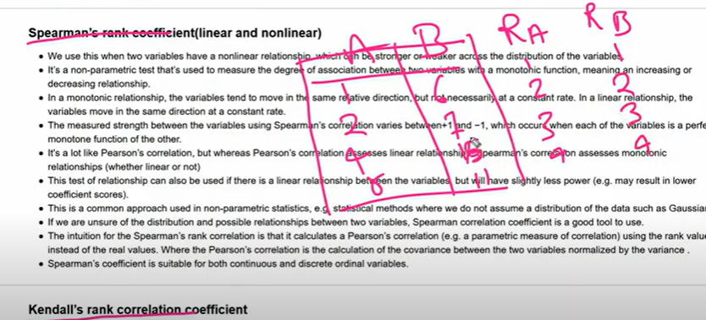

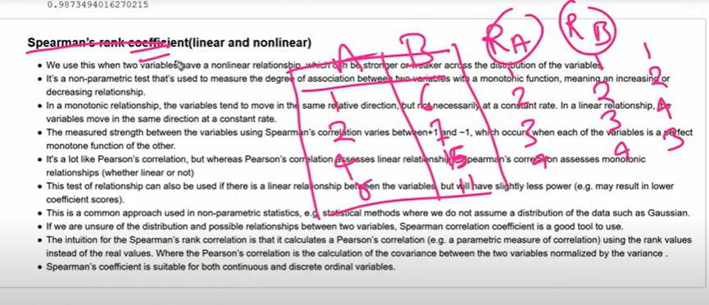

[Feature Selection using Correlation and Ranking Filter methods -Check Multi-collinearity- Tutorial 5 - YouTube](https://www.youtube.com/watch?v=nwM9ScrFVEU&list=PLYkT78pxW-otjquYUvP_IcUBUYUbYygeu&index=5)

Parametric test depends on distribution

Non-parametric test doesn’t depends on distribution

**Forward Feature Selection |Sequential Forward Selection|Wrapper Method**

**In wrapper method**

If I have x,y,z,c,d,e as features

Then q is my output or lable value

Take two features and q and fit to model and evaluate

Or 3

4

Combination of features which gives best result

**Forward selection:**

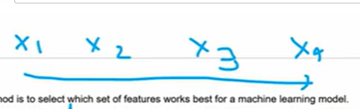

**Directions of feature selection will be like**

**1 feature(x1,x2,x3,x4)------ if x2**

**2 features(second iteration x2x1,x2x3,x2x4)**

**3 features**

**Best combination with best results will be selected**

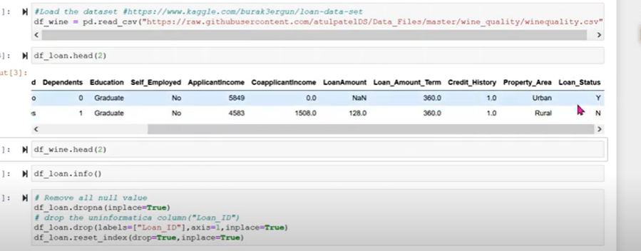

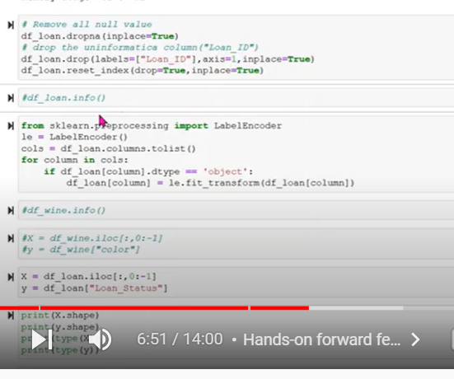

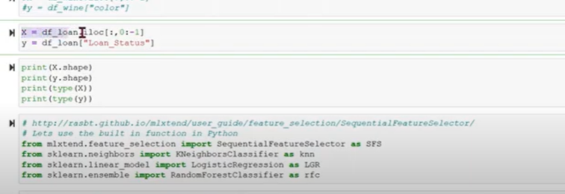

**Mlxtend, sequential feature selection for forward selection**

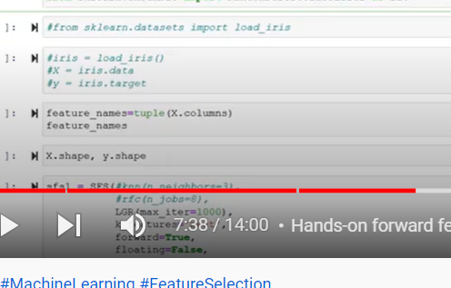

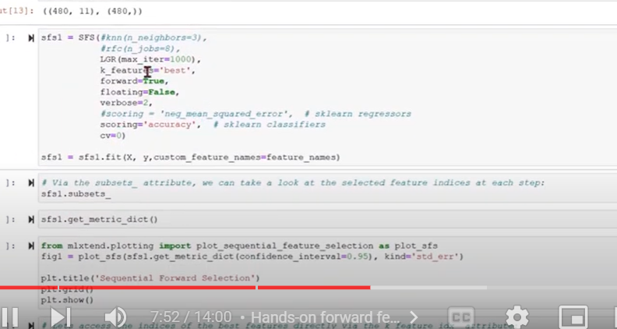

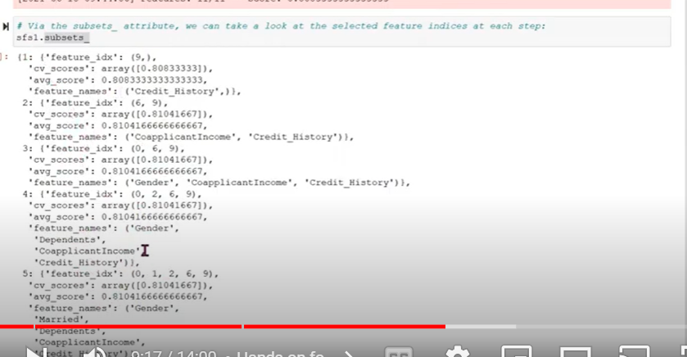

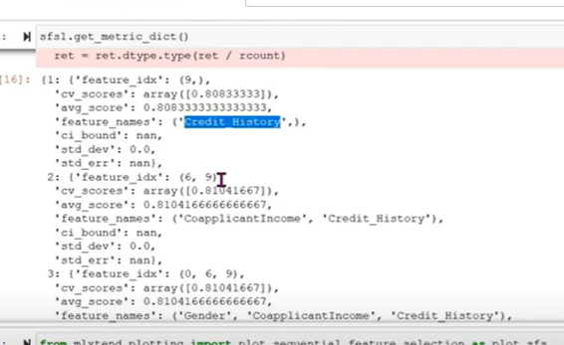

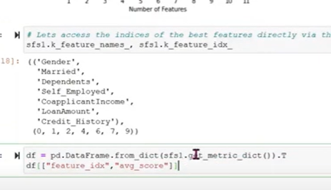

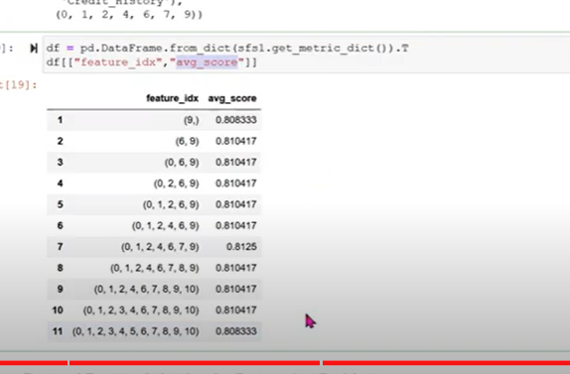

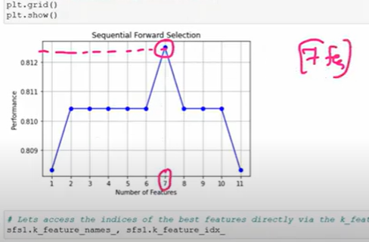

**Combination of best 7 feature gives good results**

**Regression also same**

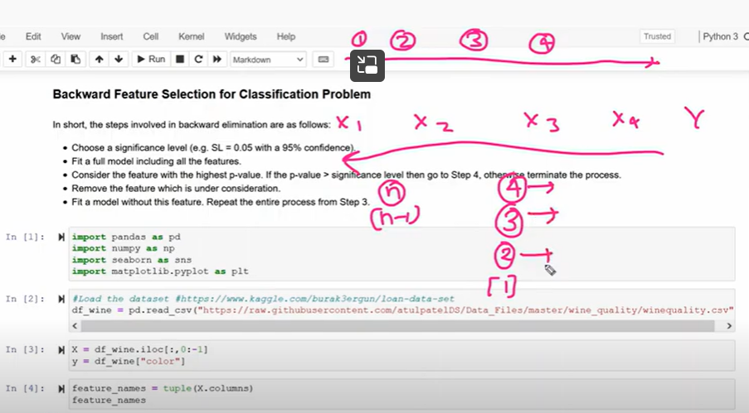

**Feature Selection Embedded Method Tree Based Algorithm Random Forest |Tutorial 11**

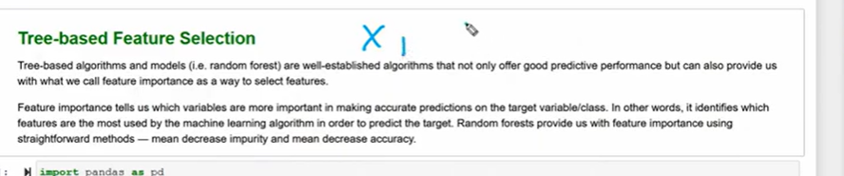

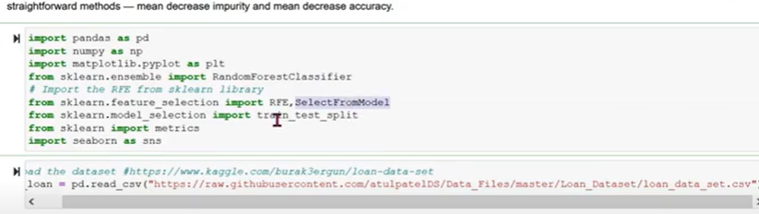

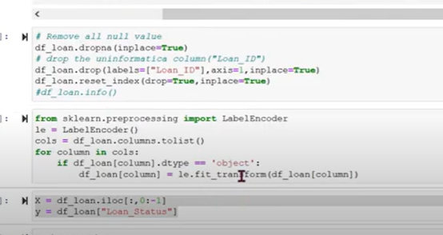

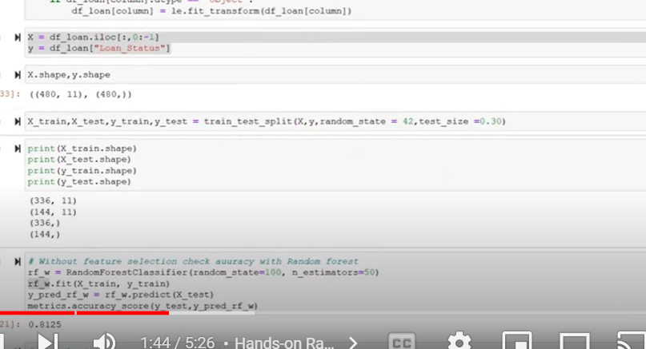

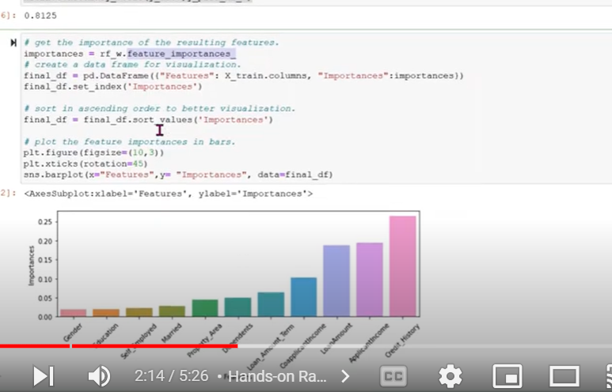

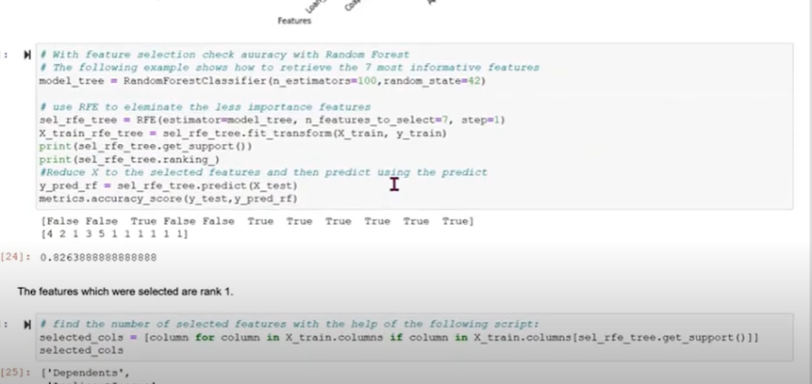

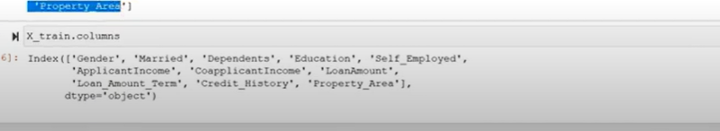

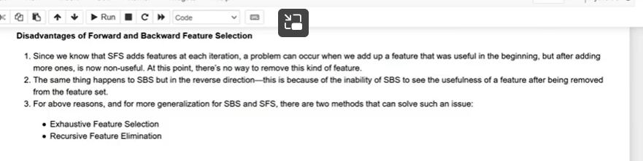

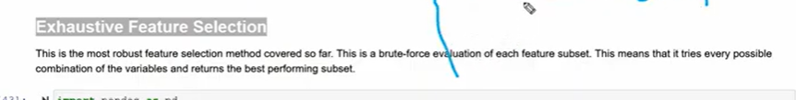

It selects all permutations and combination and check accuracy

Very expensive computationally

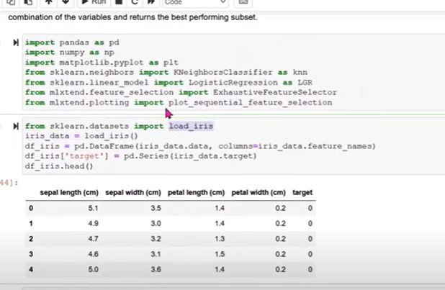

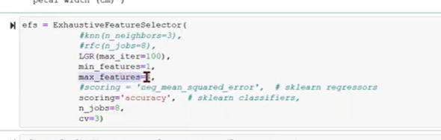

[Exhaustive Feature Selection | Wrapper Method Part 3 | Tutorial 9 - YouTube](https://www.youtube.com/watch?v=0ciQ-FzhrQw&list=PLYkT78pxW-otjquYUvP_IcUBUYUbYygeu&index=9)

**Feature Selection Embedded Method Lasso L1 Regularization**

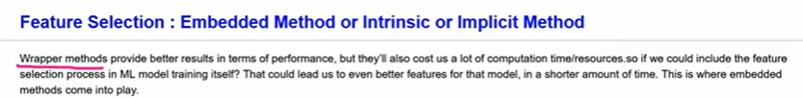

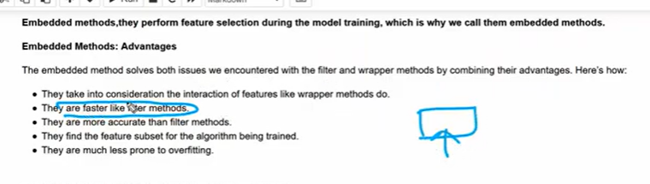

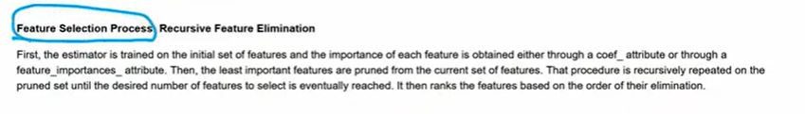

1. Regularization
2. 2. Tree based

**Overfitting :**

Training : less erroe

Testing : larhe error

Both have large variance

To overcome we use regularization

It uses penalty to modify line

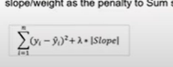

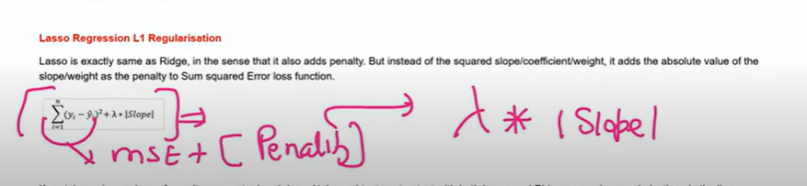

Multiple regression

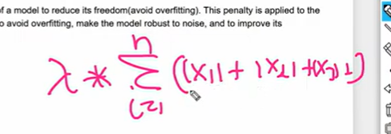

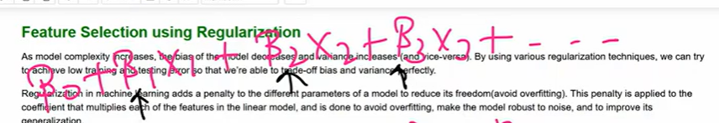

Beta is slop

If we increase lamda it handles manages slop of each feature

If we increases lamda the coefficient of unimp features will become zero

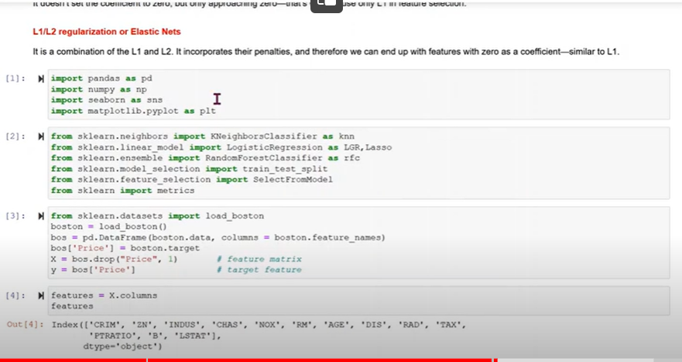

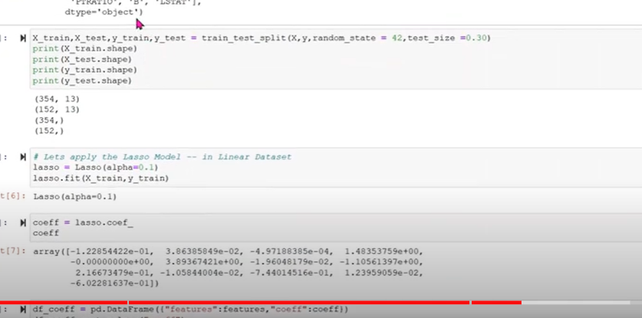

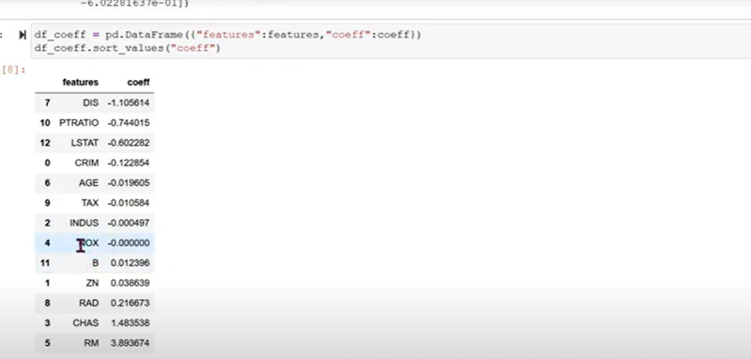

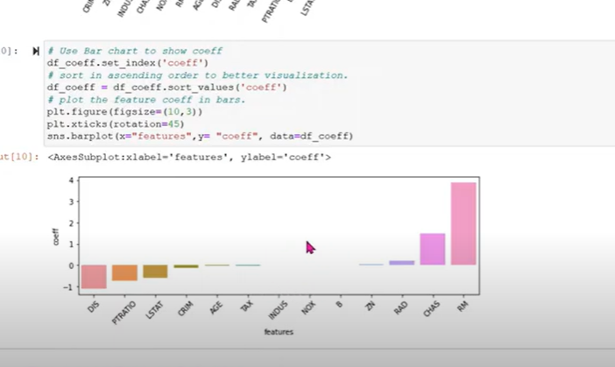

**Categorical Feature selection using chi squared | Hands-on with Scipy and Python part1**

Scipy library

**Test of goodness of test**

How my categorical variable with population: checked with goodness of fit

Second:

**Test of independence:**

If I have two categorical values: a and b

To check whether these 2 categorical values are independent or dependent

This will be used in feature selection

Hypothesis testing

H0: there is no relationship between a and b

H1: there is relationship

Alpha: 0.05

Significance: .95

P:

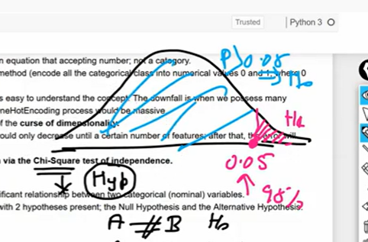

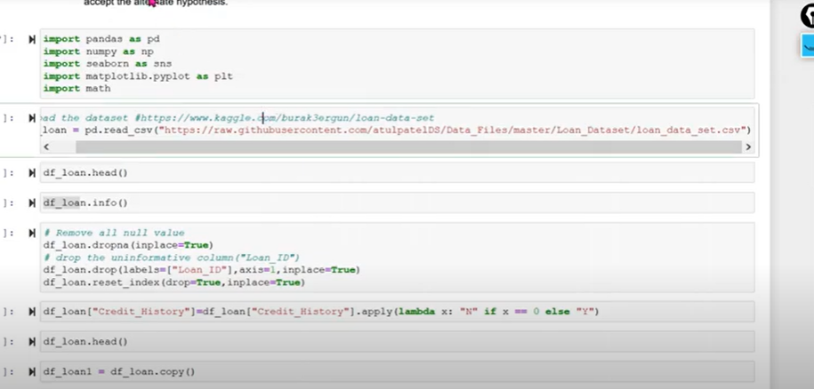

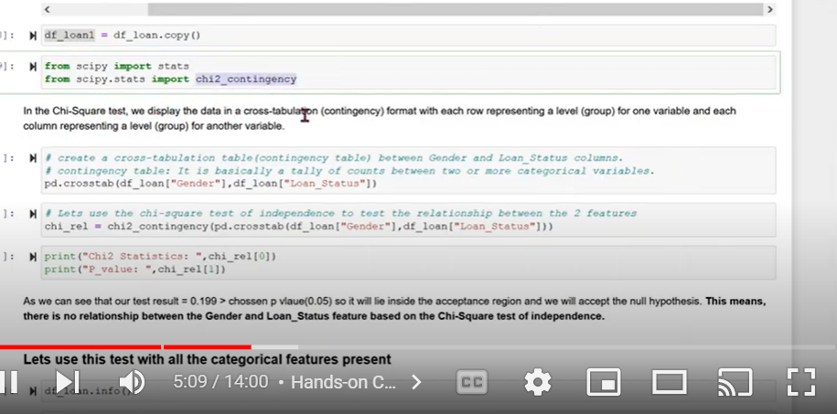

We use contingency table

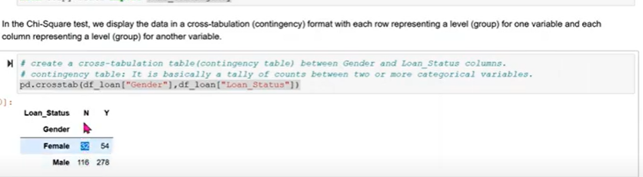

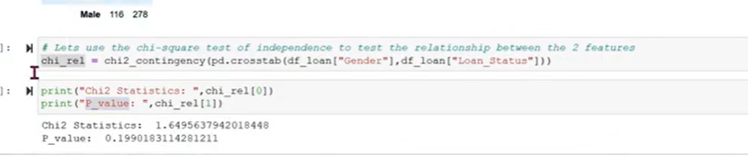

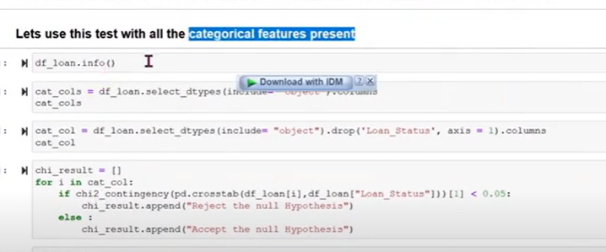

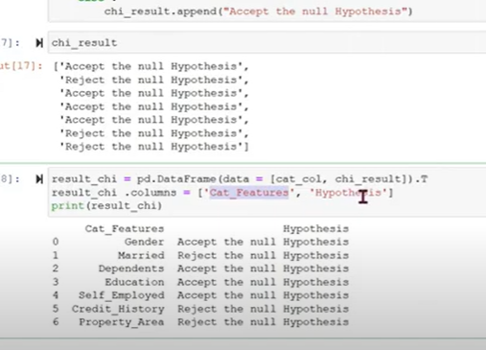

If we have multiple classes in categorical features

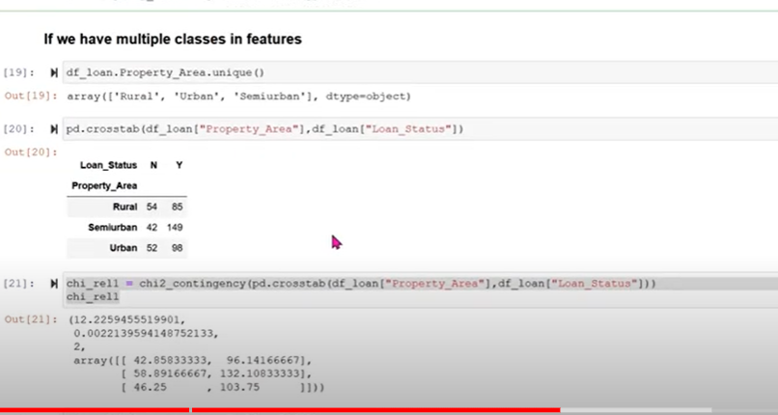

Contingency feature will be like above

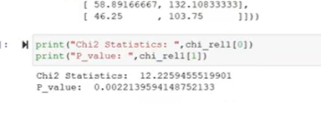



For this we wil be using dummy variable

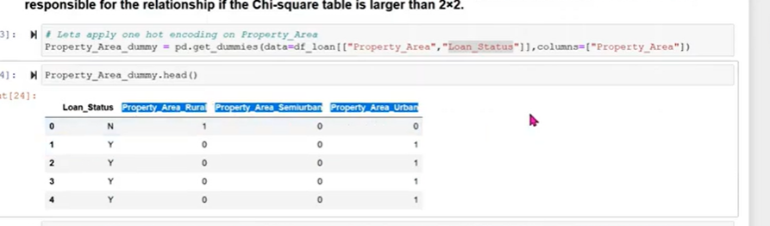

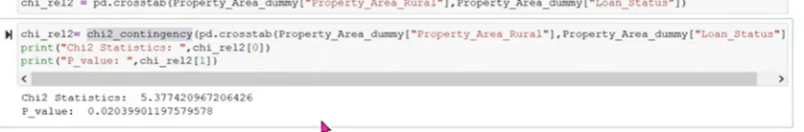

What is the problem when we have 3 classes

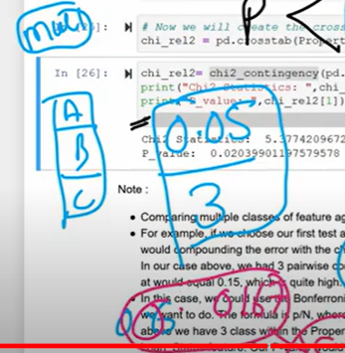

0.05 alpha/number of classes

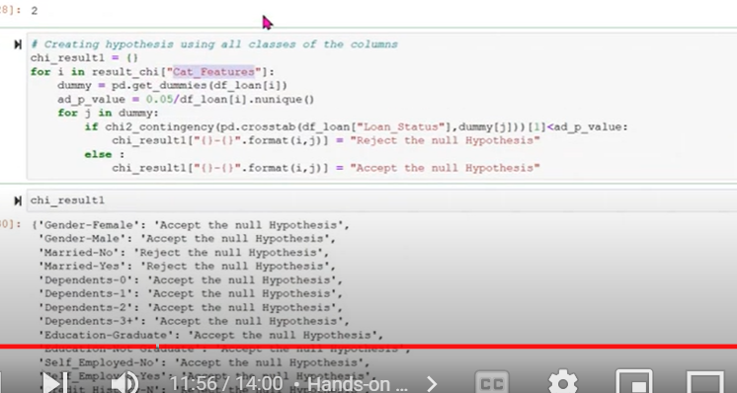

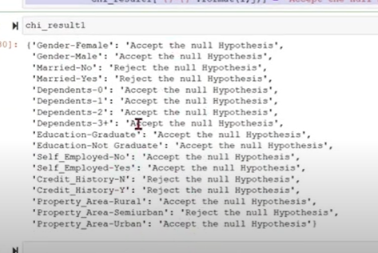

Reject null hypothesis : will have relationship

**Categorical Feature selection using chi squared |Hands-on with Sklearn and Python part2|Tutorial 13**

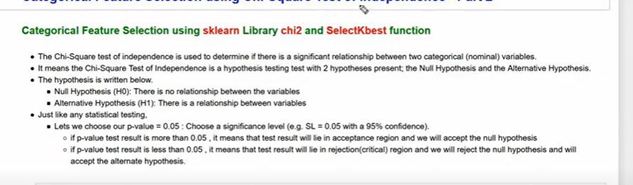

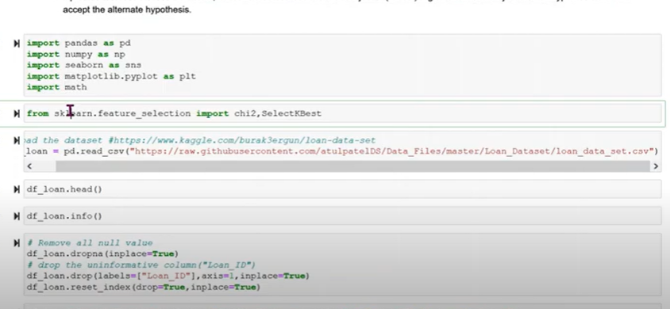

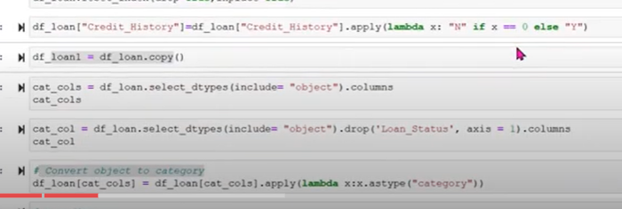

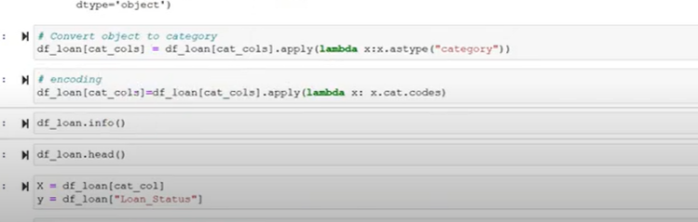

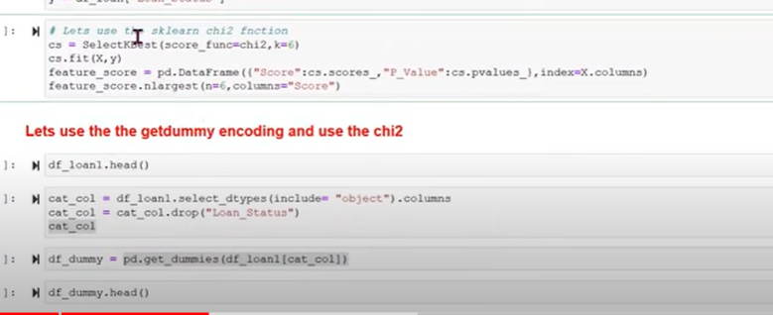

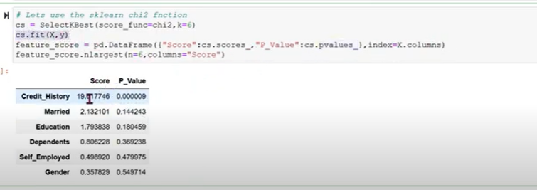

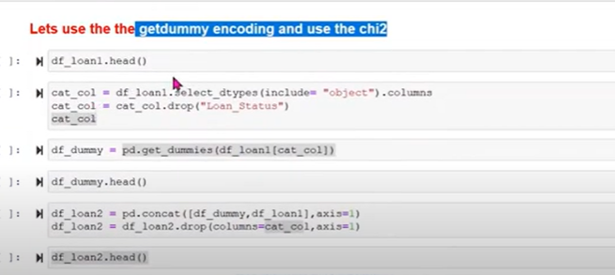

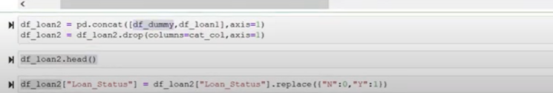

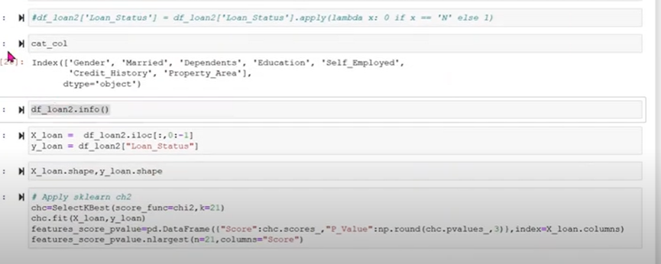

[Categorical Feature selection using chi squared |Hands-on with Sklearn and Python part2|Tutorial 13 - YouTube](https://www.youtube.com/watch?v=2PbfYO7fu3I&list=PLYkT78pxW-otjquYUvP_IcUBUYUbYygeu&index=13)s

Data science channel

[Bhavesh Bhatt - YouTube](https://www.youtube.com/c/BhaveshBhatt8791/playlists)